How to Count out a Driver

- Click “Shifts” from the Hub’s main tabs

- Click “reconcile” by Team Member name

- Note: The different tabs shown represent things that may need to be addressed while reconciling the Team Member’s shift. Tabs in red require action to be taken in that tab
- Enter credit card tips
  - Click “Payments” tab
  - Enter tips on credit orders
    - Can enter either tip amount or total amount
  - Click save on each one or click save all after all have been entered
    - Don’t “settle” credit cards until the end of the reconciliation process

- Collect cash amount due
  - Click on “Bank” to show the summary
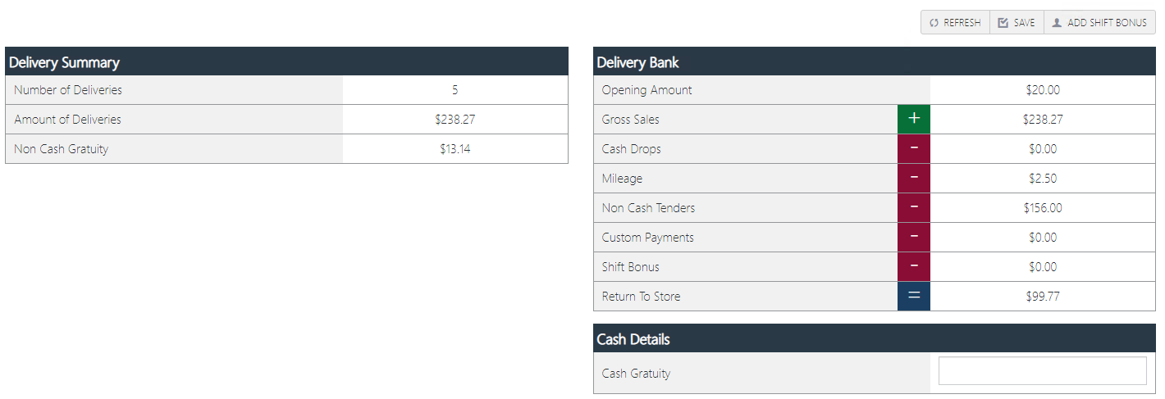

“Return to Store” is the amount the Driver owes the store. That amount is their initial Bank (usually $20) plus the total sales from the orders they delivered, minus any cash drops, mileage for deliveries, non-cash tenders (credit cards, which includes their tips), custom payments, and shift bonus.
- Once the Driver has given the amount due to the store, enter the amount of cash gratuity they received and enter into the “Cash Gratuity” section. (How much Cash tips they are claiming)
  - Click “Save”

NOTE: Cash gratuities will be saved and show on the payroll report

- Settle the credit cards assigned to the Team Member
  - Click on “Payments”
  - Settle each credit card one by one, or click the “Settle All” button

- Clock out Team Member (If they’re shift is done)
  - Click on “Shift Segments” tab
  - Click “Clock Out” under the Actions column

- Click on “finalize shift” once all tabs have been confirmed as complete and accurate.

