There may come a time that you run out of a certain item and need to get it from a grocery store or from other Topper restaurants. All proprietary items, such as Sausage or Pepperoni, must be obtained from a Toppers Pizza location. Items such as Green Peppers or Tomatoes can be store bought.

If you are doing a food transfer with another Toppers location, you will need to pay that store for the items you are transferring to your store. Below are the two ways to do this:

- Food Transfer: NO CASH EXCHANGED
  - Cloud>Inventory>Deliveries
  - Click “Add Delivery”
  - Choose vendor from drop down list
  - Choose “Food Transfer Buy/Sell” as Type of delivery
  - Enter invoice number (make up a number)
  - Enter invoice date
  - Enter delivery date
  - In “Items” section, click “Add/Remove”
    - Find transferred item in the inventory list, click the item, click the green arrow to add the item, then click “ok”
  - Enter in how many cases are being transferred in the “Quantity” field
  - Click on the “Calculate Estimate” button within the “Unit Cost” field to calculate the total cost of the items transferred
  - Enter subtotal amount (Should match “Order Cost” amount above)
  - Enter “0” for Delivery Charges” and “Taxes”
  - Click “Save”

*If store “1” is transferring product to store “2”, store “1” should enter the transaction as “Food Transfer (Sell), and store “2” should enter the transaction as “Food Transfer (Buy).

- Entering Food Bought/Sold Cash: PRODUCT PURCHASE FROM A STORE OR A TOPPERS WITH CASH.

  - Cloud>Inventory>Deliveries
  - Click “Add Delivery”
  - Choose vendor from drop down list
  - Choose “Food Bought/Sold Cash” as Type of delivery
  - Enter invoice number (make up a number)
  - Enter invoice date
  - Enter delivery date
  - In “Items” section, click “Add/Remove”
    - Find purchased item in the inventory list, click the item, click the green arrow to add the item, then click “ok”
  - Enter in how many cases were purchased in the “Quantity” field
    - E.g. If 2 bottles of Coca-Cola were purchased, you would enter .083 as the quantity (2 bottles / 24 bottles per case = .083)
  - Enter the appropriate value in the “Unit Cost” field so that the “Order Cost” matches the total amount paid for the product that was purchased
    - E.g. If the price paid for 2 bottles of Coca-Cola was $2.50, the Unit Cost would be $30.07 (See example below)
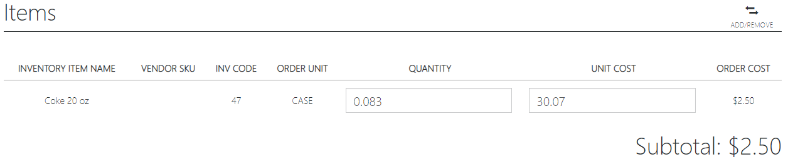

  - Enter subtotal amount (Should match “Order Cost” amount above)
  - Enter “0” for Delivery Charges” and “Taxes”
  - Click “Save”

- If the “Food Bought/Sold Cash” is between two Toppers locations:

  - If store 1 is selling product to store 2, store 1 should enter the transaction as FOOD SOLD (CASH)
  - Store number 2 would enter the transaction as FOOD BOUGHT (CASH)

- Fill out a Food Transfer Form and use it to invoice the store purchasing the food.

  - Fill out a Food Transfer Form. Give both stores a copy.
  - The store that the food was transferred from would send the form to their accountant, and they would bill the store that received the food.

