Daylight Savings Time Procedures
*Daylight savings time begins/ends on the Saturday business day at 2am (technically Sunday).
On the Sunday AM, here is a quick rundown on what needs to happen:
- DO NOT change the time at 2am
- Stay open until your regular closing time
  - When clocks turn back 1 hour, it’s recommended to stay open 1 additional hour
  - When clocks turn forward 1 hour, it’s recommended to NOT close 1 hour earlier than usual
- Close bookwork as usual
- AFTER bookwork is closed, log back in and change the Windows time BEHIND/AHEAD one hour (to match Daylight savings time). DO NOT check the box to automatically adjust daylight savings time.
- Don’t wait until Sunday dayshift to adjust the time. If you do, any online orders that are placed before the time is changed will have an hour time mismatch.
Make sure that the Sunday opening manager double checks that the time has been adjusted. Also make sure that the box to automatically adjust daylight savings time is NOT checked.
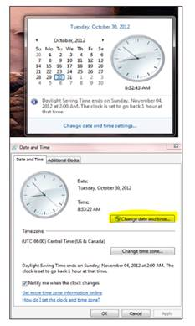
** Breakaway will NOT be available if there are issues at 2am. Call the Toppers Tech Support number 866-991-6775

