Insider Till Checkout - ASSIGNED

WHEN TILL IS ASSIGNED TO A SPECIFIC TEAM MEMBER (RECOMMENDED)

- HUB>Shifts
- Click “reconcile” by Team Member name

Note: The different tabs shown represent things that may need to be addressed while reconciling the Team Member’s shift. Tabs in red require action to be taken in that tab

- Claim Web Orders the Team Member should have assigned to them
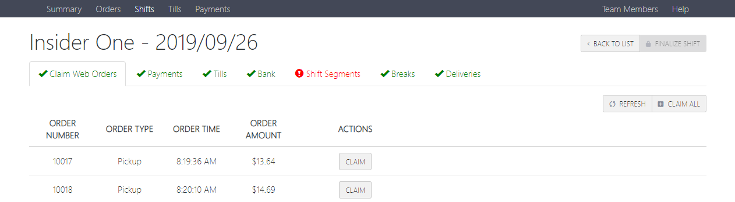
  - Click “Claim Web Orders” tab. Any online pick-up orders that are CC will show in this list
  - Click ‘Claim’ for any orders that have tips that should be assigned to this team member.
  - Once an order is claimed, the payments will appear in the “Payments” tab, and the order will be removed from this list.

- Enter credit card tips
  - Click “Payments” tab
  - Enter tips on credit orders
    - Can enter either tip amount or total amount
  - Click save on each one or click save all after all have been entered
    - Don’t “settle” credit cards until the end of the reconciliation process

- Pay tips to Team Member
  - Click on the “Bank” tab to display gratuities
  - Pay Team Member the amount shown in the “Non-Cash Gratuity” section

- Settle the credit cards assigned to the Team Member
  - Click on “Payments”
  - Settle each credit card one by one, or click the “Settle All” button

- Reconcile cash
  - Click on “Tills” tab – Cash amount needed will show under the “Cash Expected” column
  - Count all cash and coins in the till – Total should equal “Cash Expected”

- Reset Till
  - Count the till out to the appropriate Opening Amount (Usually $100)

- Make a cash drop for the remaining amount of cash after the till has been counted to the appropriate Opening Amount –
  - Click on the “Tills” tab
  - Enter the amount under the “Cash Drop” column and click save – Cash Drop receipt should print

- Close and count out till
  - Click “Tills”
  - Click “Close” under “Actions column
    - Doing this tells the POS/Hub that the Team Member’s till is now closed and no longer in use
  - Click “Count” to see till summary
  - Enter the amount of cash counted (Opening till amount + other cash received) to display the amount over/short
  - Click “Save”

- Clock out Team Member (If their shift is done)
  - Click on “Shift Segments” tab
  - Click “Clock Out” under the Actions column

- Click on “finalize shift” once all tabs have been confirmed as complete and accurate

- Drop remaining cash with Cash Drop receipt into safe

Insider Till Checkout- TILL NOT ASSIGNED

If the till is set up to be used by multiple people throughout the day or shift, then it is recommended to pay out non-cash gratuities as those Team Members’ shifts end, rather than doing it all at the end of the business day.
- Paying CC tips for TM
  - Find the CC receipts that have tips on them from the till
  - Click “Shifts” from the Hub’s main tabs
  - Click on “Reconcile” next to the appropriate Team Member’s name

- Note: The different tabs shown represent things that may need to be addressed while reconciling the Team Member’s shift. Tabs in red require action to be taken in that tab
  - Click on the “Payments” tab to show all non-cash order for that Team Member
    - Enter tips as appropriate
      - Can enter the tip amount or total amount
    - Click “Save”
    - Click Settle
    - Pay tips to the Team Member

- Reconciling the till
  - Enter all non-cash tips and pay appropriately to Team Members (See “Paying CC tips for TM” above)
  - Click on “Tills” from the Hub’s main tabs
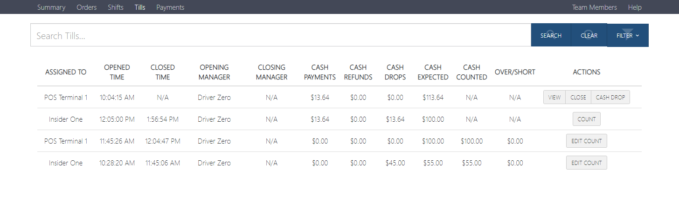
  - Reconcile cash
    - Click on “View” next to the appropriate till
    - Cash amount needed will show under the “Cash Expected” column
    - Count all cash and coins in the till – Total should equal “Cash Expected”
  - Reset Till
    - Count the till out to the appropriate Opening Amount (Usually $100)
  - Make a cash drop for the remaining amount of cash after the till has been counted to the appropriate Opening Amount
    - Click on “Cash Drop” next to the appropriate till
    - Enter the amount and click save – Cash Drop receipt should print
  - Close and count out till
    - Click on “Close” next to the appropriate till
      - Doing this tells the POS/Hub that the till is now closed and no longer in use
    - Click “Count” to see till summary
    - Enter the amount of cash counted (Opening till amount + other cash received) to display the amount over/short
    - Click “Save”

  - Drop remaining cash with Cash Drop receipt into safe

