HOW TO CONDUCT 4th Written Warning-Termination
Last Modified on: (3/20/17)
Part of Discipline and Termination procedures

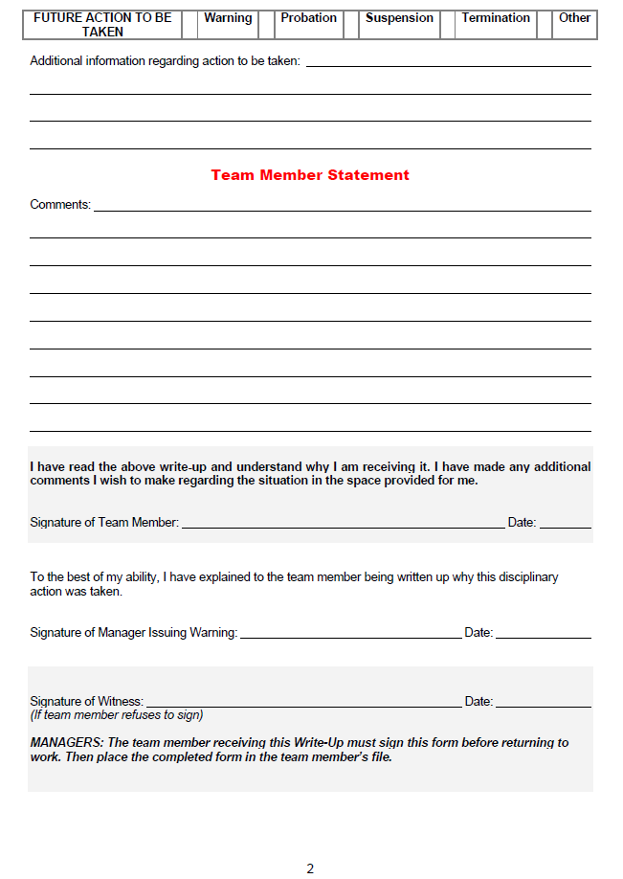
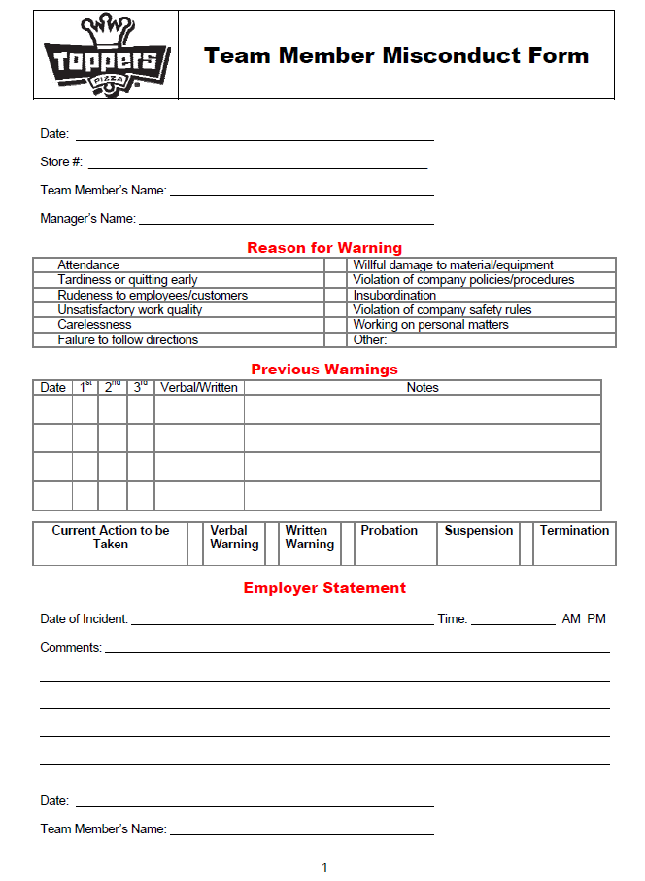
Progressive discipline gets a bad name. Remember, whenever we are conducting the following procedure its important for both parties to keep a level head, and to know this is the opportunity for the Team Member to improve performance, and goal set with their manager to greatly improve performance.
- Step 1: If this is a major company procedure violation, or you have followed through with the verbal, 1st written, 2nd written, 3rd written (suspension) for minor violations termination may be the appropriate next step
  - EX: Matt came off suspension, and was 15 minutes late for his next shift back after being written up time and time again for timeliness.
  - EX: Matt came into work intoxicated (1st warning immediate termination)
- Step 2: Schedule a short meeting, either on the spot or a couple days later.
  - If meeting is scheduled for a later date, the Team Member it is recommended the Team Member not work any shifts
  - It is not recommended to wait until the end of their shift to terminate them
- Step 3: Document the final incident resulting in termination using the “Team Member Misconduct Form”
  - Fill in the date, the store # Team Member’s name, and Manager on duty’s name
- Step 4: Check the box highlighting what company procedure was violated by the Team Member, or writing in one in the line stating “other”
- Step 5: Fill in any previous warnings Team Member received prior to this warning, including dates, and important notes
  - Previous warnings should be located in their personnel file
- Step 6: Since this is a 4th warning circle “termination” in the current action to be taken box
- Step 7: Document the incident in the “employer statement” box including dates and times of the incident
- Step 8: Document any additional information about the violation you would like the Team Member to know in regards to the future actions to be taken
  - EX: “Matt has been warned on “X” previous dates that we will not tolerate him being late for work. As a result we will be parting ways as of today.”
- Step 9: Sign and date misconduct form as the “manager” issuing warning
- Step 10: Sit down with Team Member and let them know they are being terminated for “X” reason. Try to keep this conversation as short and to the point as possible focusing only on the infraction that resulted in termination.
- Step 11: Retrieve uniform & hat
- Step 12: Retrieve store key
  - If they do not have store key on them at the time, it is recommended to let them have 24 hours to return the key to the store. If they fail to do so in this time frame, you may choose to take further action, such as sending a police officer to their residence to retrieve the key.
- Step 13: Let ex-Team Member know how they will receive their final paycheck
  - You may choose to mail it to their residence if you don’t want them back in the store
- Step 14: Escort ex-Team Member out of the building
- Step 15: Have witness Team Member present during termination sign and date the “witness” section of the employee misconduct form
- Step 16: Place final termination warning in ex-Team Member’s personnel file
- Step 17: If a Shift Leader, AM, or GM was the individual terminated change all safe codes
- Step 18: No matter what Team Member was terminated, change all door codes to make sure your store remains secure

