Policies and Procedures Overview
All Team Members are required to follow policies and procedures, but as a leader the focus changes from simply following them as an individual to upholding and enforcing them with your team. And when you begin to change your focus, you will begin to think differently about the true importance of each policy and what it means in the grand scheme of things.

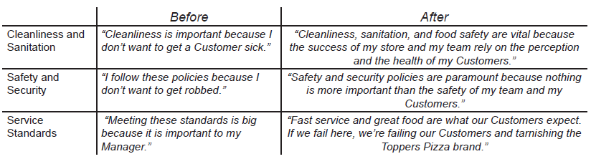
A Shift Leader or MIT must be able to uphold policies and procedures when they’re running the shift. This is an important piece that ensures that all shifts are run well, even when the Manager(s) isn’t working. The store leadership team must be unified. When processes, policies, and procedures are followed consistently, standards have a much higher likelihood of being met, and Team Members have a clear definition of what success truly means.
There can be big, negative impacts when even one leader doesn’t follow the policies and procedures when they’re in charge of shifts. This impact often affects Manager-Team Member relationships and overall store culture.
Examples of Negative Effects
- Undermines other leaders
- Tension within store leadership team
- Sets low standards for Team Members
- Standards aren’t met
- Customers notice
- Bad culture
- Unsafe work environment
When a Team Member goes against a policy, they either didn’t know about the policy, or they made a choice to go against it. When they don’t know about a policy, it’s because there wasn’t a clear enough expectation set with them. However, if they know the policy and still violate it, they are making a decision to go against it. As a Shift Leader or MIT, it’s important to know which of these happened. It is always best practice to talk with the Team Member about the “why”. “Why did you violate this policy?” “Did you know what the expectation was with this policy?” From there, you will be able to address the issue appropriately.
Most of the time, violations of policy can be fixed with simple conversation. The following can be a guideline for most conversations regarding policy violation:
- Ask the Team Member to talk in private
- View the conversation as a coaching opportunity; not a slap on the wrist
- Explain what the Team Member did wrong
- Ask them if they knew they were doing anything wrong
- Explain how the violation affected the store/other Team Members/Customers/etc.
- Ask them to follow the policy going forward
Depending on the severity of the situation, it may be necessary to relay the information to the GM, or even call them immediately. Severe violations, such as theft, should be dealt with immediately, and most likely will require that a GM is called.

